Writing First Python Program
Topics: Print Statement
Coding Tasks:
- Write a program that display Name, City, and Location.
- Write a program that prints the following patterns
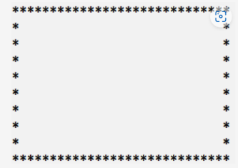

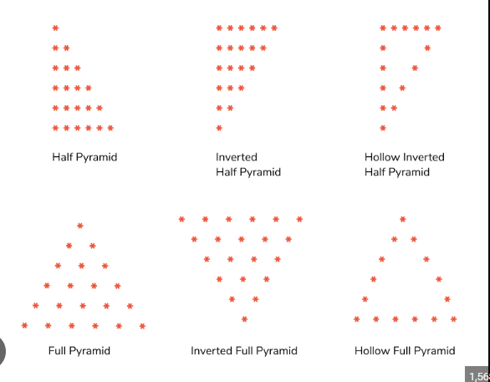

Converting Input into Output
Topics: variables, Data Types, Input Statement, Assignment Operators, Memory ,IPO Cycle,
Coding Tasks:
- Write a Python program that takes the length and width of the rectangle from the user and prints its area. Area = length * width
- Write a program that asks for the user's name and then prints a greeting message.
- Write a program that asks the user for their favorite color and prints a message including that color.
- Write a program that asks for the user's birth year and calculates their age.
- Write a program that asks for two numbers and prints their sum, difference, product, and quotient.
- Write a program that asks for two words and then prints them together as one word.
- Write a program that converts temperature from Celsius to Fahrenheit.
- Write a program that asks for the user's name, age, and city, and prints this information in a formatted message.
- Write a program that asks for a word and a number, then prints the word repeated that many times.

Code Reusability
Topics: Functions, Parameterized Functions, Value Returning Functions
Coding Tasks:
Perform above tasks using Functions.

Case Study: The School Cafeteria Problem
Imagine you are helping the school cafeteria staff calculate bills for students.
- Each student buys some items (e.g., sandwich, juice, and fruit).
- For every student, the cafeteria needs to calculate:
  - The total bill.
  - The discounted price (10% discount for members).
  - The final bill with tax.
Now, suppose there are 50 students in line. Without functions, you would need to write the same code 50 times to calculate each student’s bill.

Example without functions (pseudocode-like idea):
# For Student 1
total1 = 50 + 20 + 10
discount1 = total1 * 0.1
final1 = total1 - discount1 + (total1 * 0.05)

# For Student 2
total2 = 30 + 15
discount2 = total2 * 0.1
final2 = total2 - discount2 + (total2 * 0.05)

# ... and so on for 50 students
This is repetitive, boring, and inefficient.

The Function Approach
Instead, we can write a function once and reuse it for all students:
def calculate_bill(prices, is_member):
total = sum(prices)
if is_member:
total -= total * 0.1 # 10% discount
final = total + (total * 0.05) # 5% tax
return final

# Now just call the function for each student:
student1 = calculate_bill([50, 20, 10], True)
student2 = calculate_bill([30, 15], False)
student3 = calculate_bill([40, 25, 15], True)

print(student1, student2, student3)
✅ We wrote the logic once, and used it for many students.
✅ If rules change (say discount becomes 15%), we update the function in one place.
✅ The program becomes shorter, cleaner, and easier to read.

Takeaway for Students
Functions in Python are like tools you create yourself. Instead of repeating the same steps, you pack them into a reusable block. They help you:
- Reduce repetition
- Increase readability
- Save time
- Avoid mistakes

PROJECT
Title: Personalized Adventure Game
Description:
Create a simple text-based adventure game where the user makes a series of choices to create a story. This project will involve collecting user input and using functions to generate different parts of the story.
Project Plan:
Introduction: Print a welcome message and explain the game.
Collect User Information: Ask for the user's name, a friend's name, and a favorite place.
Create Functions: Write functions to generate different parts of the story based on user input.
Print the Story: Use the functions to print the complete story.
Expected Outcome:
Welcome to the Personalized Adventure Game!
In this game, you'll create your own adventure story.
One sunny day, {name} and {friend_name} decided to go on an adventure.
They traveled far and wide until they reached {favorite_place}, a place full of mystery and wonder.
In the end, {name} and {friend_name} discovered that the true treasure was the friendship they shared.
Functions to implement:
introduction()
collect_user_info()
create_beginning(name, friend_name)
create_middle(name, favorite_place)
create_end(name, friend_name)
print_story(beginning, middle, end)
main()

